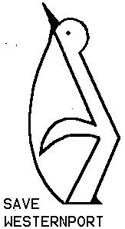Westernport and Peninsula Protection Council Inc
Incorporated Association Reg. No. A15886H ABN 984 610 14730 PO Box 9 Hastings Vic 3915
_______________________________________________________________________
Newsletter December 2012
__________________________________________________________________________________________

WPPC AGM 10.00am –Earlier than usual
Sunday January 13th 2013
Hastings Hall- High Street
Between Salmon Street and Marine Parade
Next to Hastings Library - Mel 154 k11 Change of venue
Followed by lunch
Guest Speaker- Chris Chandler
Chris’s family moved to French Island in 1968 and like Gerard Durrell, one of his favourite authors, he got to know the native wildlife. He was fortunate to be around when the scientist engaged to carry out the Shapiro Study came off the ferry. They were directed to the Chandler family who had come to know where everything was. Chris accompanied his parents showing the scientists birds, vegetation, tidal areas etc. He joined the formal study of birds in1972 led by Richard Loyn and Des Quinn, at the age of twelve.
Chris has recently returned to Westernport after many years aboard, and will be introduced by Dr Brian Cuming who received welcome coaching from Chris on the Ecology of Westernport when he unexpectedly found himself replacing WPPC President Dr Bill Carroll following Bill’s untimely death in 1986, both as President and Conservation representative on the recently formed and later influential Westernport Regional Planning and Co-ordinating Committee advising the Minister for Planning.
ordination committee advising the Minister for Planning.

Hastings Hall
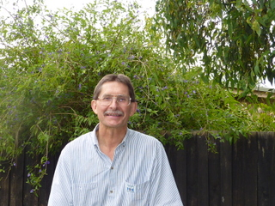
Chris Chandler will offer a special perspective on the values which make Westernport Bay a Wetland of International Importance under The Ramsar Convention. Chris remembers WPPC luminaries of the past. He remembers Bill Carroll’s fiery speeches, Joe Tilleard’s tireless organisational wizardry, and Ken Hayes’ patient diplomacy. He will recall some of the historical environmental battles in which he participated from the earl 1970’s and relate them to present day outcomes.

Because Chris has a commitment on French Island the meeting will start at 10.00am sharp and his presentation will be the first item on the agenda.

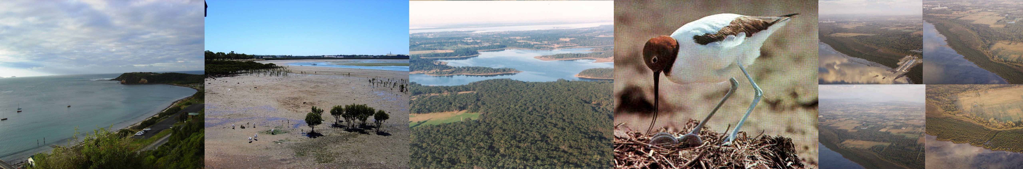
Visit our website http://www.wppcinc.org


WPPC and Devilbend Foundation shared a stall at The Balnarring Sustainability Fair…… Saturday 23rd of November was a busy day for WPPC. We had a colouring competition that kept kids busy all day in the shade. We had entries in three categories 5 and under, 6 and 7 year olds, and eight and over. The competitors received a free mangrove poster and the three winners got a beautiful book purchased from Teacher Resource Bookshop Hastings.
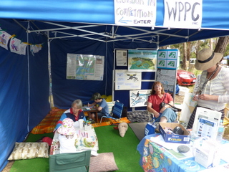
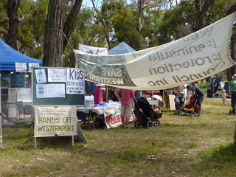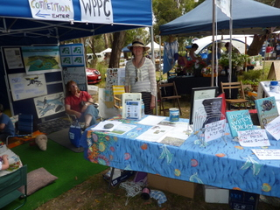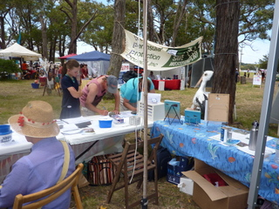
We had letter-writing stall with dozens of letters signed and envelopes addressed to various politicians. We had a display, Information sheets and discussions. It was and well worth the big effort. Thank you Louise Rawlings, Sheila Kerr, Annabel, Liz, myself -Karri and Tim, and members for coming, and Dolphin Research Institute for loan of display boards. Devil bend’s Jamie and Julie, Marnie, Roger.



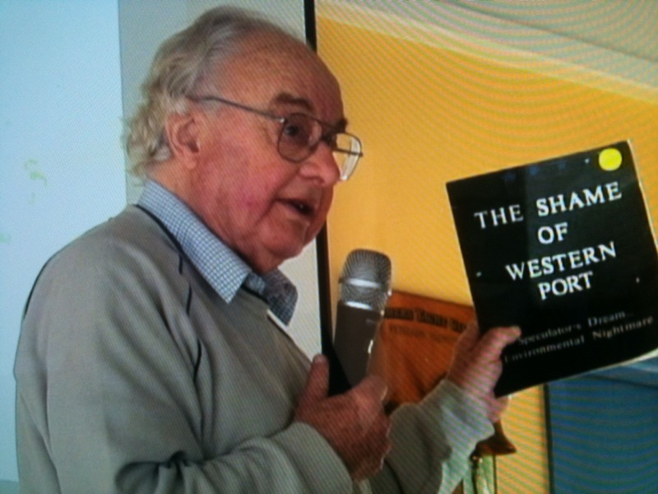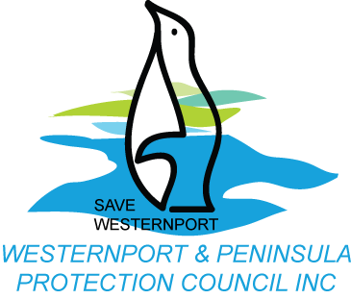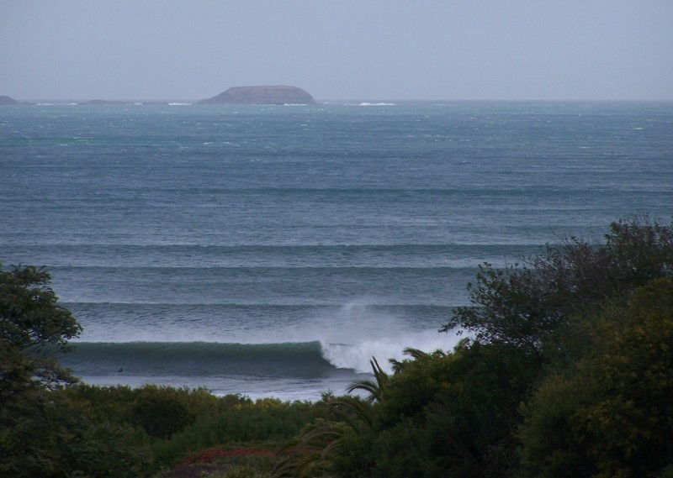


Westernport Bay and the Proposed Port Of Hastings Development
In November 2012, (last month) The Hon Tim Pallas announced withdrawal of support for the proposed Port of Hastings, on economic grounds. Now is the time for a broader economic study of the value of a healthy Westernport Bay to the economy. The local economy is based on the area being suitable for recreation for Melbourne, and for tourism, fishing, surfing, school and University camps etc. The value of the area for preventative savings to the health budget should be determined also. There needs to be a broad economic study done to include the value of a Healthy Westernport Bay to the State.
Locals should not hope for a long term growth in jobs from a port, as after construction they employ very few people compared to the industries based on a healthy Bay listed above.
In January 2009 Ralph Kenyan, CEO for Port of Hastings announced that an EES will proceed to evaluate suitability for port expansion of stage one of a three stage process. Any EIS/ EES should be for all three stages of a proposal. This was promised by Tim Pallas and Madden. Building the first stage of the port would mean so much infrastructure development that resisting stages two and three would be politically impossible for scientists and community groups against the juggernaut. An EES for stage one alone would be breaking an important promise to the community, and the worst sort of trickiness.
Despite claims that an oil spill in Westernport can be responded to by the National Oil Spill Plan, there is ample evidence to demonstrate that even a moderately sized spill (such as a spill of bunker oil, say 500 tonnes) could not be effectively responded to even using the very best world technology, due to the tidal movements and exposed tidal mud flats and mangroves in The Bay.
Global experience proves oil spills can happen anywhere, anytime. The foundering of the Iron Baron at the mouth of the Tamar River, Tasmania, on 10 July 1995, resulting in only 2% of the oil carried being recovered from the sea (contrary to excited claims that the oil spill plan worked very well) and Tasmanian government estimates published four years later that between 7000 and 17000 Fairy Penguins were destroyed as a result, as well as lots of other wildlife. Every ship has enough oil to create a major spill.
Prior to the expenditure of taxpayers’ funds on EES investigations, the scientific evidence and the global experience of oil spills should be reviewed.
42% of Westernport Bay is exposed tidal mud flats at low tide. That means close to half of The Bay’s bottom (benthos) is in contact with its surface twice a day. Any oil on the surface would thoroughly coat and kill the life embedded in the bottom. According to the Melbourne Water Seminar- Dr Jeff Ross’s study, the benthic life is responsible for converting nitrogen in the water to harmless nitrogen gas. Excess nitrogen can result in dangerous algae blooms and eutrophication. We need these creatures to stay alive for the Bay to remain healthy. They provide an ecosystem service.
At Present less than 2 million containers come into The Port of Melbourne each year. The Port of Melbourne will have enough capacity for 8 million containers per annum. Then the plan is to use either Bay West or Westernport Bay as a container port for any extra capacity needed above 8 million. As this will be containers for other cities why not use their ports instead of developing Westernport Bay? The Port of Hastings expansion should only be considered within a National Transport Plan.

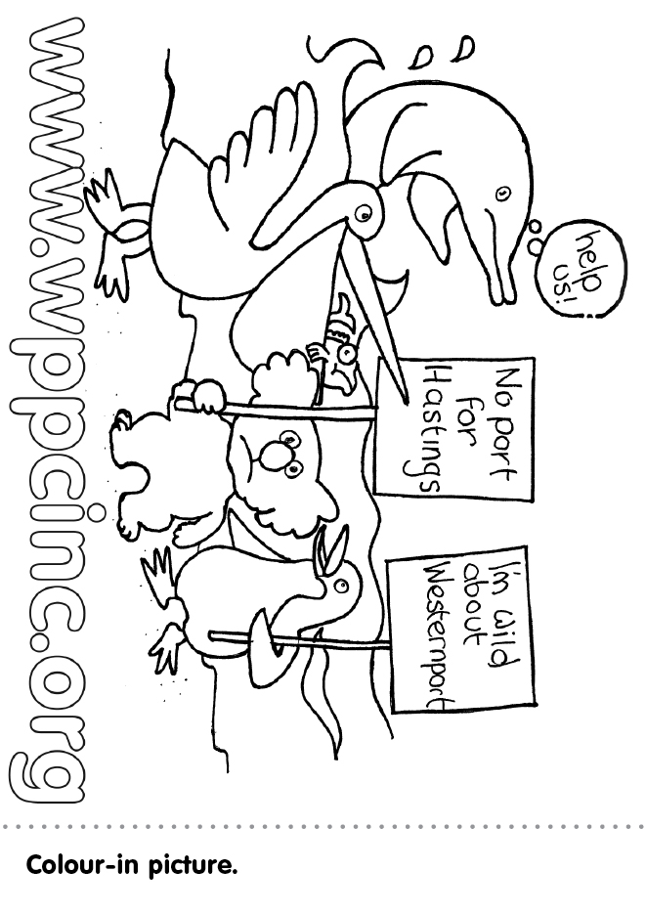

Westernport and Peninsula Protection Council Inc.

Founded in 1971, the programs of the Council are aimed at preserving and restoring what remains of our precious natural environment in Westernport Bay and its hinterland. An important part of our activities to that end is to ensure that proper planning processes are observed by Government at all three levels and that community consultation is a fundamental component of planning. We have achieved a high reputation for approaching such matters through careful study of principles and attention to detail.
Prompting community awareness of important conservation issues has also been high on our agenda for the past 30 years. We continue to explore ways of informing the public of their natural assets and of the current and ongoing threats opposed to them by inappropriate and destructive developments.
The activities of Council are managed by an executive committee of nine, elected at the annual General Meeting, which is held on a Sunday early in January. Membership is by application and subscription and confers voting rights and a say in the Council’s activities. The Committee has the power to co-opt additional members during the year.
Additional help on Committee and in a range of other ways is always welcome. Please indicate on the subscription form if you have any special skills or interests which may be helpful in our campaigns.
For further information about our activities please contact:
Karri Giles (President /editor) 59 832 072 Sheila Kerr (Treasurer) 59 786889 Annabel Richards (Acting Secretary)- 59831294
Other members of Committee are: Liz Sarrailhe, Ruth Marriot, Linda Drewitt, Kathie Strickland, Meg McMillan.
I would like to support the work of Westernport Peninsula Protection Council Inc.
Subscription: (not tax deductible) - subscriptions fall due 1st Nov each year
$10 individual $15 family $5 concession $………
Donation: (tax deductible for amounts of $2 or more - see below) $……….

I/we enclose a cheque for: $______
Name:……………………………………………………………………………
Address:………………………………………………………………………….Postcode:……………….
Phone:……………………………………………
Do you want your newsletters by email? Email:…………………………………….
Please correspond by email: …….. Please send newsletters by email: ………..
I would like a receipt and have enclosed a stamped, self-addressed envelope........
Skills/interests: I would like to offer help in the following ways:
……………………………………………………………………………………………………………
The Westernport Peninsula Protection Council Inc Trust is a gift fund listed on the Register of Environmental
Organisations under Section 78(1) (a) of the Income Tax Assessment Act 1936.
Inc. no: A0015886H ABN: 98 461014 730
Please return to: Hon Treasurer, WPPC, Box 9, Hastings, Vic 3915

If undeliverable return to:
POSTAGE PAID AUSTRALIA
PRINT POST
PP 344188/10014
WPPC
PO Box 9
HASTINGS VIC 3915

Westernport & Peninsula
Protection Council Inc

WPPC AGM Sunday 13th January 2013
Hastings Hall 10am

